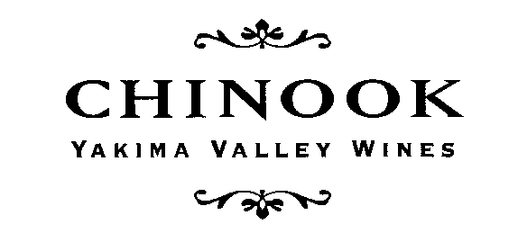
CHINOOK WINES ARE AVAILABLE AT THE FOLLOWING LOCATIONS IN WASHINGTON STATE:
2020
In King County, WA
Wine Merchants  City Cellars, Seattle  Esquin, Seattle  Grape Choice, Kirkland  McCarthy & Schiering, Queen Anne, Seattle  McCarthy & Schiering, Ravenna, Seattle  Metropolitan Markets, Seattle/W. Seattle  Mutual Fish Company, Seattle  PCC Natural Markets,  Bothell, Burien, Central District,  Columbia City, Edmonds,  Fremont, Greenlake, Greenlake Village  Issaquah, Kirkland,  Redmond & Seattle  Pike & Western Company, Seattle  Total Wine & More: Bellevue, Tukwila,  Lynnwood  Federal Way  Town & Country Market, Bainbridge Island  Wine Alley, Renton | Restaurants  Anthony’s Homeports, Greater Seattle  Blueacre, Seattle  Café Veloce, Kirkland  Dahlia Lounge, Seattle  Etta's, Seattle  Fairmont Olympic Hotel, Seattle  Jazz Alley, Seattle  Lark, Seattle  Lola, Downtown Seattle  Maximilien Restaurant, Seattle  Orfio, Seattle  Palace Kitchen, Seattle  Pike Brewery, Seattle  Steelhead Diner, Seattle

CHINOOK WINES
List of WA Accounts, cont.
2020

Western WA, outside King County
Wine Merchants  Bay Leaf, Whidbey Island (Coupeville)  Compass Wines, Anacortes  Metropolitan Market, Tacoma  Seifert & Jones Wine Merchants, Bellingham  Slough Food, Edison | Restaurants  Adrift, Anacortes  Anthony’s Homeport, Bellingham  Inn at Ship Bay, Orcas Island  Inn At Langley, Whidbey Island  Restaurant Marche, Bainbridge Island  Willows Inn, Lummi Island  Woodfire Grill, Everett

Eastern Washington
Wine Merchants  Bonnie’s Vine & Gift, Prosser  Huckleberry's, Spokane  Rosauer's, Yakima  Stems, Yakima  Wray's Chalet Thriftway, Yakima  Vino! A Wine Shop, Spokane  Vintage Vine, Roslyn | Restaurants  Anthony's, Richland & Spokane  Arrowleaf Bistro, Methow Valley  Endive, West Richland  Freestone Inn, Methow Valley  Gasperetti's, Yakima  Suncadia Lodge, Roslyn  Valley Cafe, Ellensburg  Viscontis @ the Brewery, Leavenworth

Please call 509-786-2725 for more information!
Kay Simon & Clay Mackey, proprietors
P.O. Box 387, Prosser, Washington 99350
info@chinookwines.com

