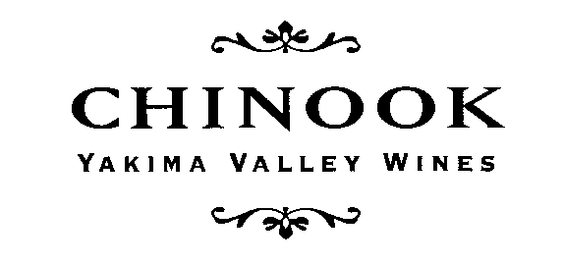
CHINOOK WINES ARE AVAILABLE AT THE FOLLOWING LOCATIONS IN WASHINGTON STATE:
2014
In King County, WA
Wine Merchants  Arista Wine Cellars, Edmonds  Bin 41, West Seattle  City Cellars, Seattle  DeLaurenti, Seattle  Esquin, Seattle  Grape Choice, Kirkland  Home Remedy, Seattle  Leschi Food Mart, Seattle  McCarthy & Schiering, Queen Anne, Seattle  McCarthy & Schiering, Ravenna, Seattle  Metropolitan Markets, Seattle/W. Seattle  Mutual Fish Company, Seattle  PCC Natural Markets,  Edmonds, Greenlake, Issaquah, Kirkland,  Redmond & Seattle  Pike & Western Company, Seattle  Total Wine, Bellevue, Tukwila, Lynnwood  Federal Way  Town & Country Market, Bainbridge Island  Vineyard Wine Shop, Seattle  Wine Alley, Renton  West Seattle Cellars, Seattle | Restaurants  Anthony’s Homeports, Greater Seattle  Brave Horse Tavern, Seattle  Café Veloce, Kirkland  Canlis, Seattle  Cedarbrook Lodge, Seatac  Dahlia Lounge, Seattle  Daily Grill, Seattle  Etta's, Seattle  Flying Fish, Seattle  Fairmont Olympic Hotel, Seattle  Il Bistro, Seattle  Jazz Alley, Seattle  Lark, Seattle  Local 360, Seattle  Lola, Downtown Seattle  Luc, Seattle  Maximilien Restaurant, Seattle  Monsoon, Seattle & Bellevue  Palace Kitchen, Seattle  Pike Brewery, Seattle  Ray’s Boathouse, Seattle  Restaurant Marche, Bainbridge Island  Seatown, Seattle  Serafina, Seattle  Tanakasan, Seattle

CHINOOK WINES
List of WA Accounts, cont.
2014

Western WA, outside King County
Wine Merchants  Bay Leaf, Whidbey Island (Coupeville)  Compass Wines, Anacortes  Island Wine Company, Friday Harbor  Metropolitan Market, Tacoma  Seifert & Jones Wine Merchants, Bellingham  Slough Food, Edison  The Wine Loft, Olympia | Restaurants  Adrift, Anacortes  Anthony’s Homeport, Bellingham  Duck Soup Inn, San Juan Island  Inn at Ship Bay, Orcas Island  Inn At Langley, Whidbey Island  Restaurant Marche, Bainbridge Island  Tulalip Resort, Tulalip  Willows Inn, Lummi Island  Woodfire Grill, Everett

Eastern Washington
Wine Merchants  Bob's Keg & Cork, Yakima  Bonnie’s Vine & Gift, Prosser  Gifts of the Vine, Ellensburg  Huckleberry's, Spokane  Rosauer's, Yakima  Stems, Yakima  Wray's Chalet Thriftway, Yakima  Yoke's Fresh Markets, Kennewick, Pasco &  West Richland  Vino! A Wine Shop, Spokane  Vintage Vine, Roslyn | Restaurants  Anthony's, Richland & Spokane  Arrowleaf Bistro, Methow Valley  Freestone Inn, Methow Valley  Gasperetti's, Yakima  Mission St. Bistro and Wine Bin, Wenatchee  Suncadia Lodge, The Inn at Suncadia &  Glade Spring Spa, Roslyn  Valley Cafe, Ellensburg  Viscontis @ the Brewery, Leavenworth

Please call 509-786-2725 for more information!
Kay Simon & Clay Mackey, proprietors
P.O. Box 387, Prosser, Washington 99350
info@chinookwines.com

